**Changes/ Notes**

Replace all Skote logo’s with Sicuro Group Logo (attached SVG)

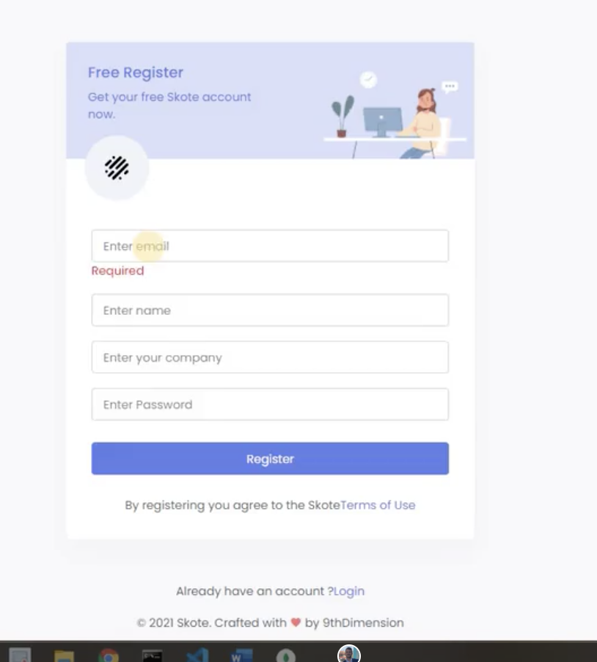

* Replace Free register with Welcome to Sicuro Group
* Remove get your free Skote account, replace with We’re excited to have you onboard.
* Remove by registering etc replace with > By registering you agree to the Sicuro Group Terms of Use (terms of use can link to here <https://www.sicurogroup.com.au/>)
* Already have an account ?Login - spacing issues should read account? Login
* Replace 2021 with 2021 Sicuro Group.
* After registration - user should be sent an email to confirm/verify their account

I also wanted the light side bar on the dashboard, please do this (image below) (If not possible that is okay but would be really good)

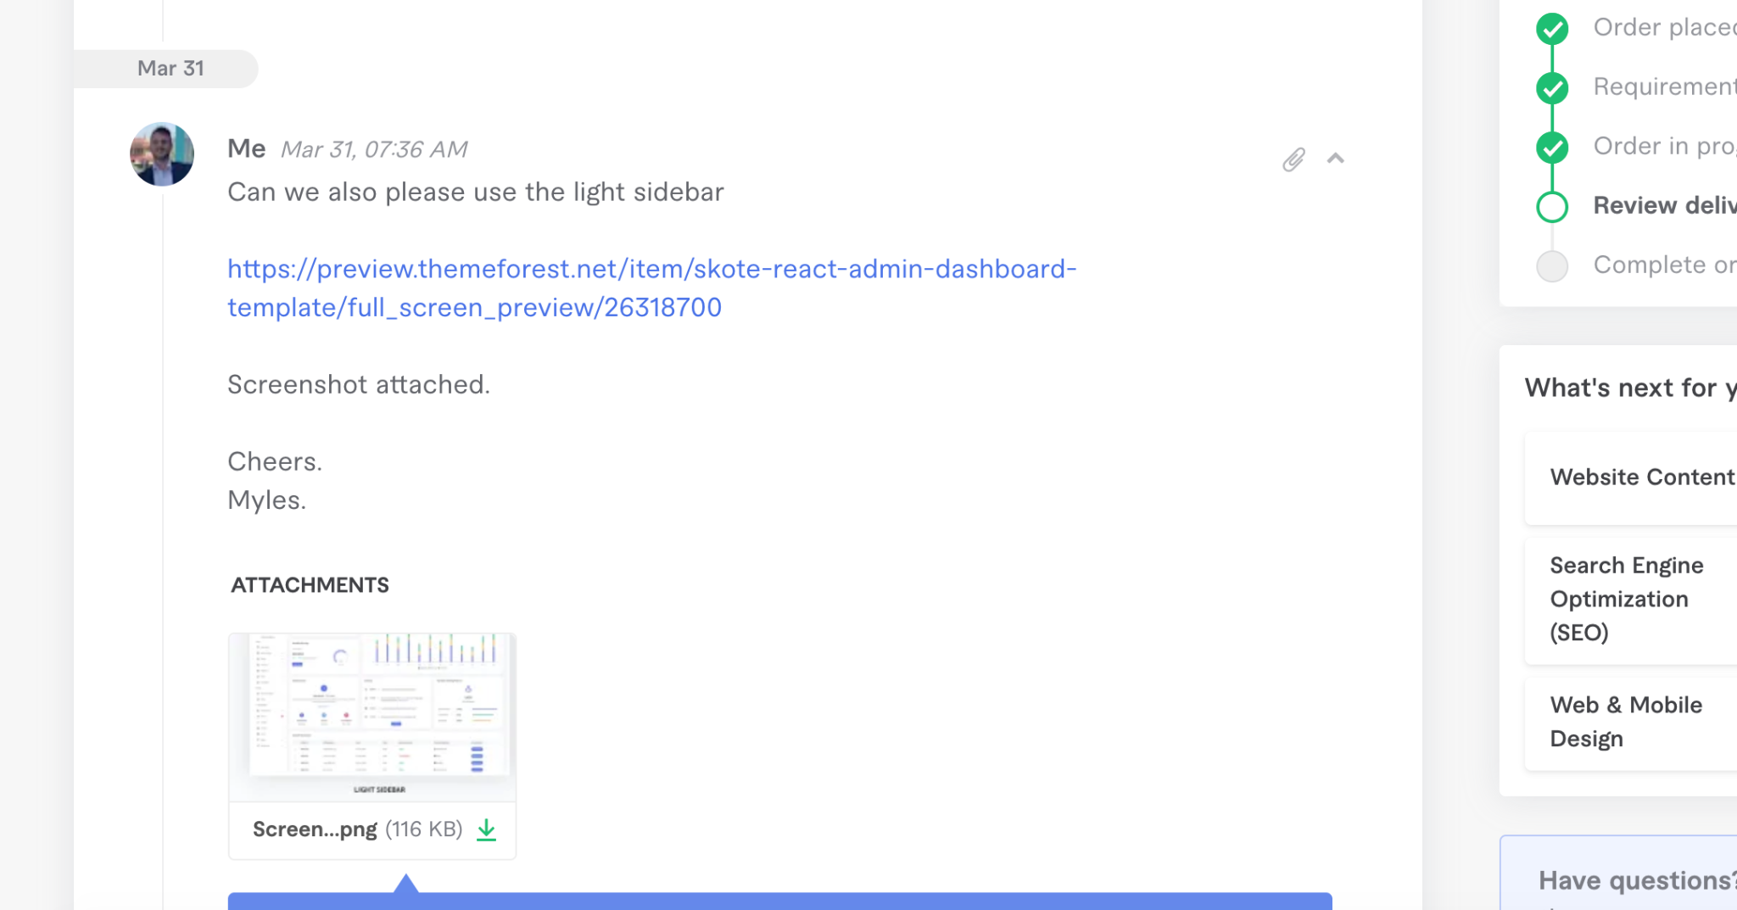

This is what a new customer **should** see - (No side menu just the onboarding checklist - below) after they register.

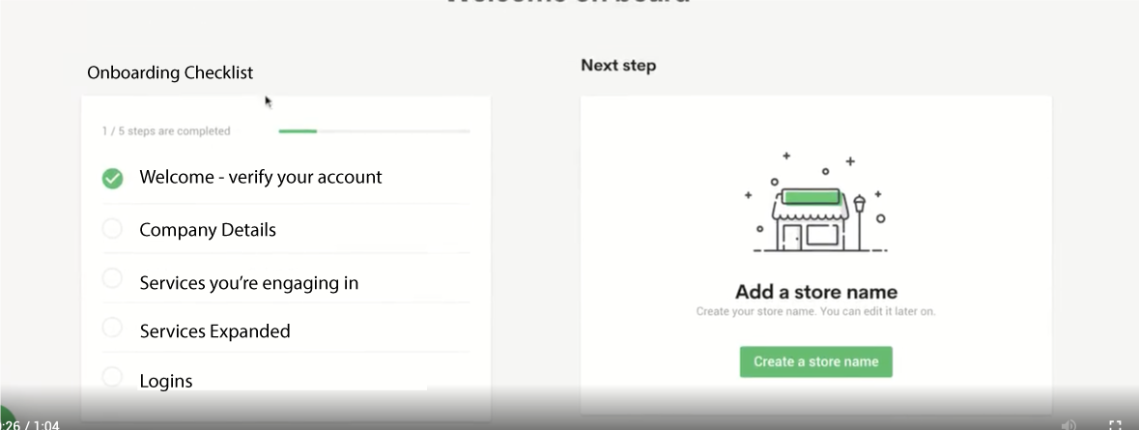

(This is just an example)

For the checklist, these sections will be the same for every customer

Include even the number of steps left

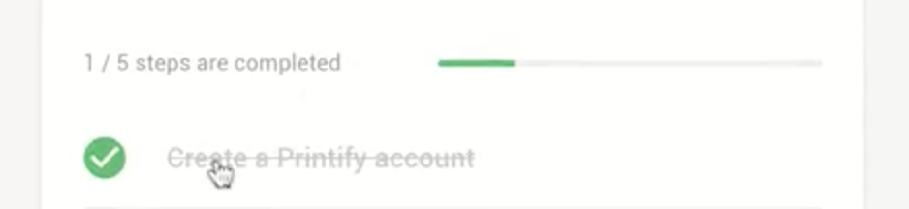

Allow customers to click on each on boarding step

SO the steps would be

* Step 0. Welcome to Sicuro Group - thanks for signing up. (verify account)
* Step 1. - Tell us abit about yourself (personal details)
* Step 2 - Registration of company details (company details)
* Step 3 - Getting to know your business (company details expanded)
* Step 4 - Services you are engaging in
* Step 4a - Services expanded

**Here is an example on the current version that isn’t right**

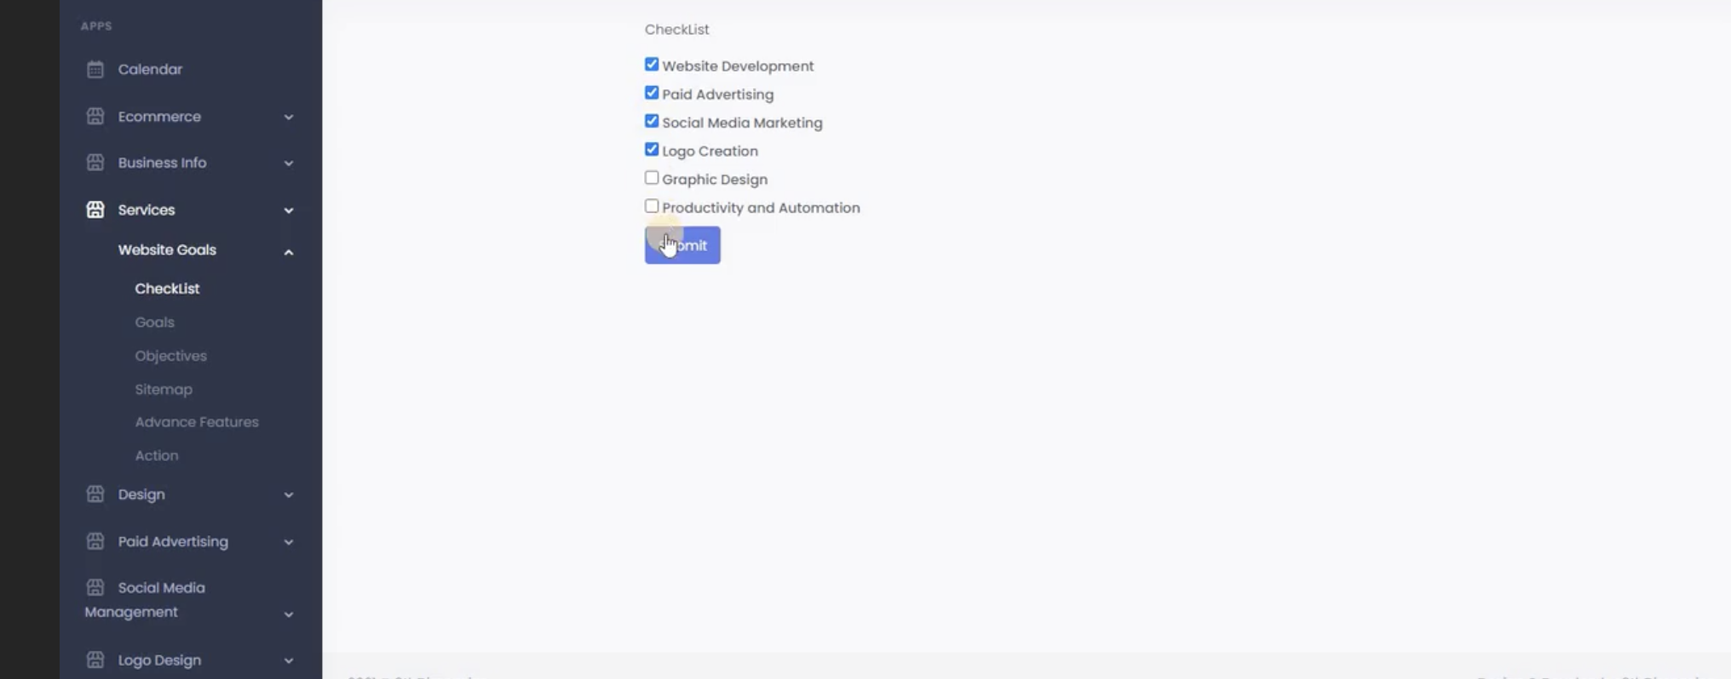

Services are independent of the website goals checklist.

-----

**Make sure there is conditional logic.**

If a customer chooses digital marketing they are presented with the digital marketing questions.

(Please include descriptions with questions and placeholders if needed)

Here are all the services questionnaires (These were included in the instructions doc)

**Website Development (Questions)**

**Section 1 - Website Goals**

* Objectives
  + What does your website need to achieve for your business? What will make this website a success for you?
* Goals
  + Please enter the most important goal of your website from the list below in the area opposite: o Promote a brand and image o Promote a product range o Improve access to information o Create a web presence o Increase sales leads o Other – (please specify)
* Call to actions
  + Please describe the action you would like visitors to take after visiting your website. (e.g. call a phone number, complete a form, make a comment etc.)
* Sitemap
  + Do you have any indication of what pages or sections the website should be made of? Please outline the pages and subpages required. (e.g. Home, About, Services/Products, Contact etc)
* Advanced Features
  + Does your website require any specific extra functionality? (e.g. online store, product catalogue, online directory, advanced search functionality, advanced online forms, newsletter subscription, Membership login area, online booking system, advanced gallery, online payment system, integration with existing software)

**Section 2 - Design/style**

* Websites you like
  + Please send us links to websites you really like. (Minimum 3) If you have one in particular you would like to emulate, let us know.
* Websites you DON’T like
  + Please send us links to websites you dislike.
* Website Colour
  + Do you have a colour preference? Y/N If Y - please let us know your colour preference.
* Website Style
  + Please describe what style of site you are looking for: (e.g. serious, professional, creative, informal, friendly, playful, corporate , modern etc.) Please describe how you would like your visitors to perceive your new site: (e.g. friendly, corporate, serious, engaging, fun, funky, cutting edge etc.)
* Content
  + Do you have the upcoming websites content ready? (e.g. text, images) Y/N Do you need help with content creation? (copywriting, photography) Y/N
* Upload Content
  + Please upload content (MS Word Doc) Or provide Dropbox, OneDrive, Google Drive details

**Section 3 - Hosting**

* Do you currently have someone who will host your website?
  + Yes
  + No
* Other information  
   Is there anything else we should know about that is relevant?
* Wordpress Logins (URL)
* Wordpress Logins (Username)
* Wordpress Logins (Password)
* C-panel Logins (URL)
* C-panel Logins (Username)
* C-panel Logins (Password)

Awesome work! We appreciate your time to complete the form. Now sit back, relax and we’ll begin the work. Your project manager will make contact shortly. Feel free to contact us at any stage – we’re in this together and hear to help.

-----

**So this would look something like this**

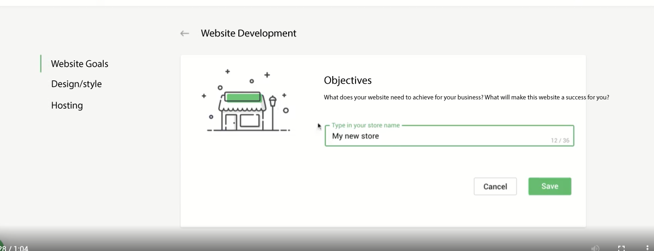

(This is just an example)

Allow customers to see the steps in the left

-------

Once a customer finishes the onboarding process then they can see the sidebar/dashboard.

In the sidebar there will only be a few navigation icons.

* Onboarding (here is where they can edit their submission/forms)
* Google Drive folder (here is where they can add in more folders/files if they need

Notes -

I can’t see this bit either or how It can be done?

